**How to register for the foreign language exam via the eHMS System (Virtual Dean’s Office)**

1) Log into the eHMS System (Virtual Dean’s Office) (https://ehms.sggw.edu.pl).

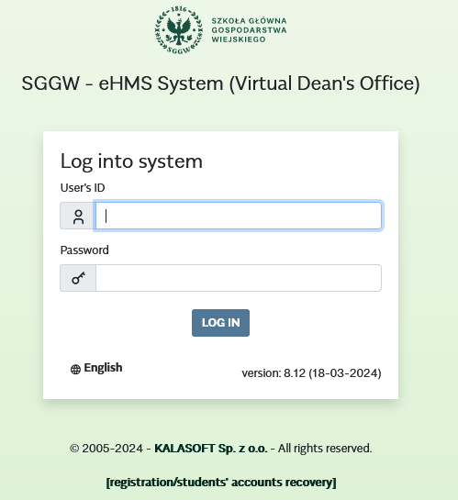

2) Select the tab “MY SCHEDULE”.

3) Choice of offer:

a) From the left-side menu, select “Teaching offers”;

b) In the “CHOICE OF OFFER” window select the academic year and semester ;

c) Below the “Go to:” information, click on “Basic schedule offer”.

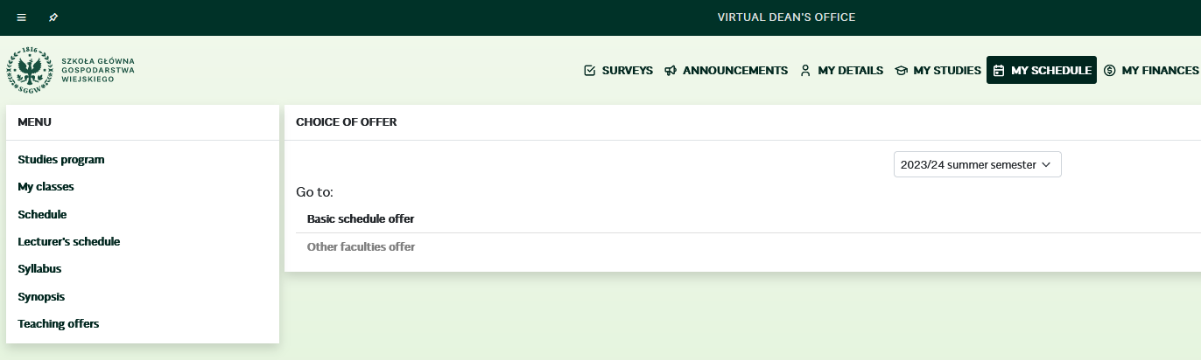

a)

c)

b)

4) In the “Basic schedule offer” window, under the word “Offer”, click on “+” (plus) next to “$PO-Offer of foreign language exams” in order to display a list of languages to be selected.

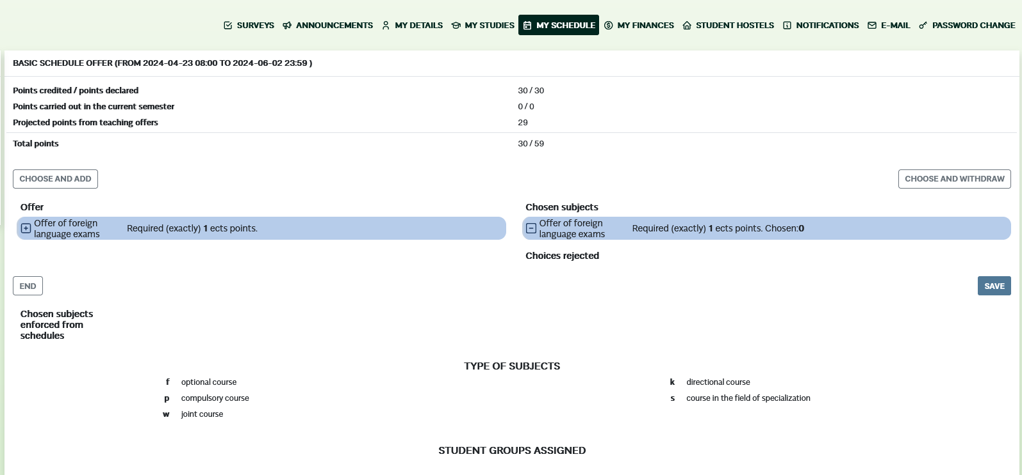

4)

5) From the list of displayed languages, select the foreign language in which you wish to take an exam:

a) Check the selected language by clicking on the square marked with the letter “w”;

b) Use the button [CHOOSE AND ADD] to navigate to the list of “Chosen subjects”.

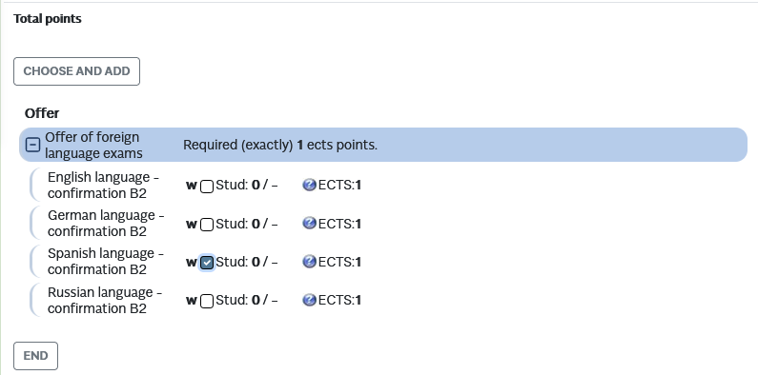

b)

a)

6) Click the [SAVE] button to confirm your selection.

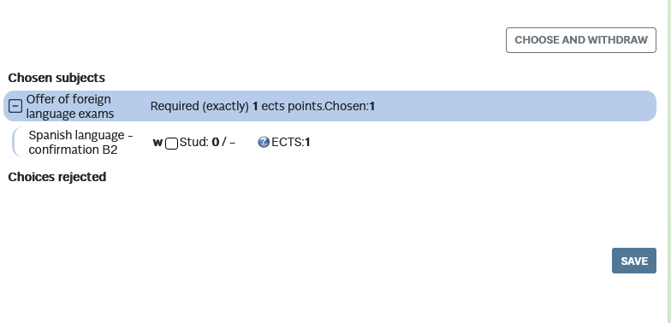

6)

The notification “Changes saved” will appear, confirming the selection of the language for the exam.

**Attention: If the selection of subjects is not confirmed, it indicates that you have not completed registration for the language exam (The choices made will not be visible in the system).**